|  |  |
| --- | --- |
|  | **Database Management Systems**  **BSCS-4**  **Department of Computer Science**  **Bahria University, Lahore Campus** |

**Assignment: [2]**

Date: Week 13, 11th December 2023

Name: ____Ahsan Waheed____

Roll No: ____03-134221-005______

|  |  |  |  |
| --- | --- | --- | --- |
| **Evaluation of CLO** | **Question Number** | **Marks** | **Obtained Marks** |
| **CLO: Analyze user requirements to design a database for the given scenarios** |  |  |  |
|  |  |  |
|  |  |  |
|  |  |  |
|  |  |  |
| **Total Marks** | | **20** |  |

**LIBRARY MANAGEMENT SYSTEM**

**Introduction:**

Libraries are vital repositories of knowledge, fostering learning and intellectual growth. However, outdated manual systems often hinder efficiency and user experience. This proposal outlines a comprehensive library management system (LMS) designed to streamline operations, enhance user engagement, and modernize library services.

**Project Scope:**

The proposed LMS will encompass the following modules:

* Cataloging and Acquisition: Efficiently manage book data, including ISBNs, titles, authors, and subject categories. Streamline procurement and acquisition processes.
* Circulation: Automate borrowing and returning of physical and digital materials. Track due dates, fines, and reservations.
* Member Management: Register and manage member information, preferences, and borrowing history. Enable online account creation and self-service options.
* Search and Discovery: Facilitate intuitive search functionalities based on keywords, titles, authors, and subject areas. Offer recommendations and personalized reading lists.
* Inventory Management: Maintain accurate inventory levels, track missing or damaged items, and trigger automated alerts for restocking.
* Reporting and Analytics: Generate comprehensive reports on library usage, member demographics, popular materials, and borrowing trends.

**Problem Statement:**

**Traditional library systems often face challenges like:**

* Manual processes: Time-consuming and error-prone data entry, borrowing/returning, and inventory management.
* Limited accessibility: Inaccessible for remote users or those with disabilities.
* Inefficient resource utilization: Difficulty tracking popular materials and optimizing resource allocation.
* Lack of user engagement: Limited interaction and communication with library members.

**This LMS aims to address these issues by:**

* Automating repetitive tasks: Streamlining workflows and saving staff time.
* Enhancing accessibility: Providing online access and user-friendly interfaces for diverse users.
* Improving resource utilization: Data-driven insights to optimize collection management and resource allocation.
* Boosting user engagement: Personalized recommendations, self-service options, and interactive features.

**Methodology Diagram (ERD):**

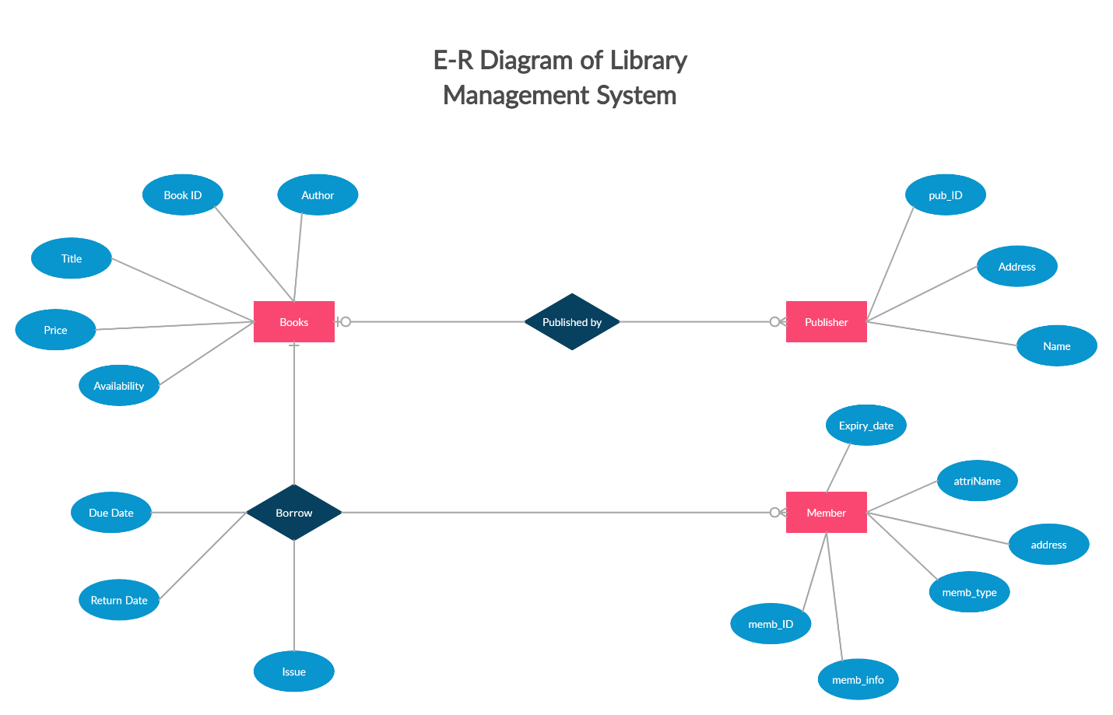

**Relations:**

1. **Book - Publisher (One-to-Many):** A book can have only one publisher, but a publisher can publish multiple books. This would involve:
2. **Book - Member (Many-to-Many through Borrow (Relationship) ):** A book can be borrowed by many members, and a member can borrow many books. This requires a separate "Borrow" table
3. **Member - Borrow (One-to-Many):** A member can have many relationships (borrowing records) in the Borrow table.
4. **Borrow - Publisher (One-to-Many):** This depends on your specific "Relationship" table design. (if we store the information).